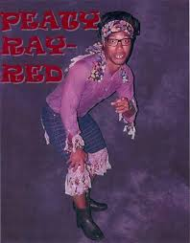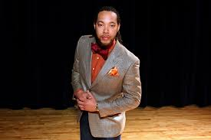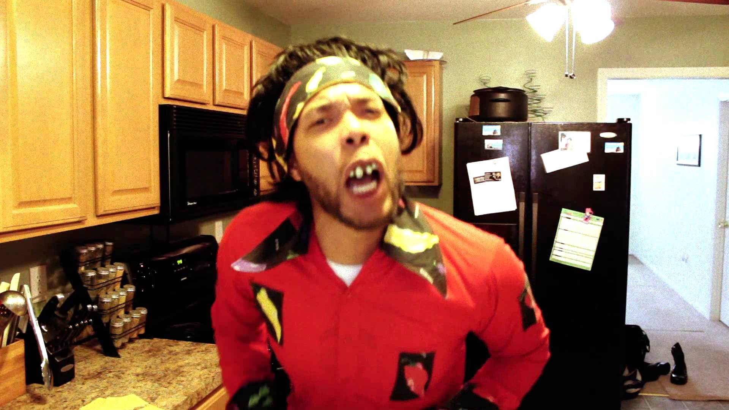
SPECIAL GUEST: GOSPEL COMEDIAN PATRICK WILLIAM,
A.K.A., PEATY RAY RED
PEW RALLY!
WHERE: UNION BETHEL CHURCH OF GOD IN CHRIST
3223 AIRLINE BOULEVARD
PORTSMOUTH, VA 23701
WHEN: SUNDAY, AUGUST 10TH, 2014 @ 3:30 PM
WHY: IN SUPPORT OF THE WORK OF THE MINISTRY
SPECIAL GUEST: GOSPEL COMEDIAN PATRICK WILLIAM, A.K.A., PEATY RAY RED
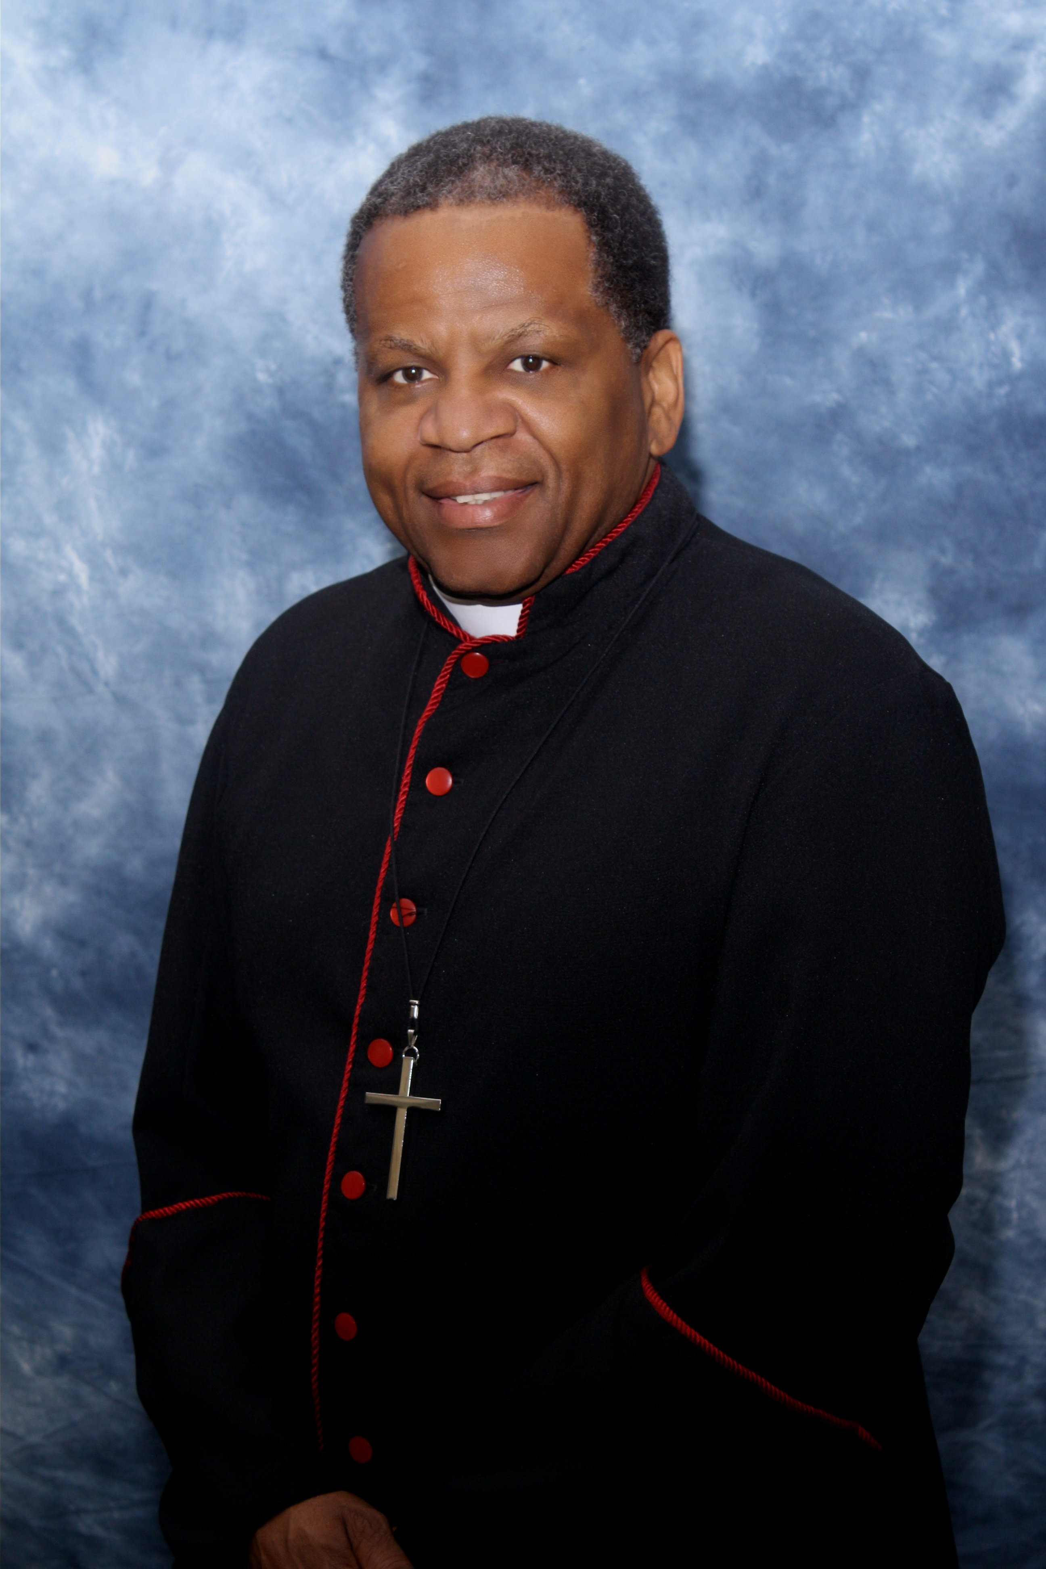
COME SIT ON A PEW TO HELP EACH PEW CAPTAIN TO MEET AND EXCEED HIS/HER GOAL TO THE GLORY AND HONOR OF THE MOST HIGH GOD!
SUPERINTENDENT HAROLD WOODLEY – PASTOR

